**Capstone Project 2015**

**3D Metal Printer**

**Cameron Tribe, Branden Driver, Brian Andrews, Ahmad Qazi**

**Project Overview:**

The team will interface a CNC machine with a MIG welder to create a 3D printer.

**Project Proposal:**

**The Goal:**

The end goal of this project is to fully integrate the MIG welder with the LinuxCNC system. Integration will include a way to control all of the functions of the welder, i.e. wire speed, maximum current output, engaging and disengaging the welder at appropriate times. In order for this to be done, electromechanical devices must be used to manipulate the knobs on the MIG welder. At the very least, the machine must be able to deposit material, reproducing a simple single object from a CAD drawing. This object is chosen to be a cylindrical tube, however, it is desired that the machine will be able to create complex structures on a single base. Precision of the deposition is not the primary concern, however it will be a requirement that the total amount of material deposited is more than the minimum tolerance of the part being created. This will allow for material to be machined away to a more precise tolerance.

**Our starting point**

The groundwork of this project has been completed by Aram Kasparov, the project sponsor. The project at its current state consists of a PC controlled CNC machine, a MIG welder, an infrared temperature sensor and a current measuring sensor. The PC controlling the CNC machine is running a Linux operating system. LinuxCNC an open-source software is used for programing and interfacing with the physical machine. Additional hardware is installed onto the PC, consisting of Mesa Electronics 5I20 FPGA based PCI Anything I/O card, 7i33 analog servo interface card and two 7i37-COM isolated I/O cards. The LinuxCNC software communicates the control signals and receives feedback through these cards. The CNC machine is a 3-axis machine-that is it can move in the X, Y and Z directions. Each axis is moved by a servo-motor and each servo motor is driven by a driver which receives its control commands from the PC. The machine is functional, though the motors will require some tuning and limit switches need to be programmed in (they are physically installed on the machine but not included in the program). The MIG/Flux cored welder is rated at 180 Amp-DC, 240 Volt with a duty cycle of 20% at 140 amps. The welder has current and wire feed adjustment capabilities for controlling the weld. These two knobs will be controlled by two stepper motors which have been installed onto the welder already. The current sensor has the ability to measure up to 225A. It has been demonstrated to be functional and will be used to monitor the current of the weld. The infrared non-contact temperature sensor is rated to measure temperatures up to 1800 degrees Celsius, though no tests have been performed yet.

Requirements:

* Must use a wire feed welder
* Welder must have a Control System
* Must measure weld temperature
* Must measure weld current
* Must use both previous parameters to estimate current quality of weld
* Must use “G code” as inputs
* And must control when material is being deposited
* Must have user interface
* Should allow for welder thermal shutdown
* May show amount of wire left on spool

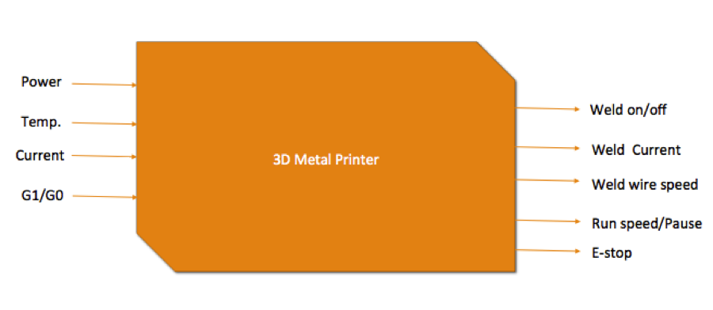

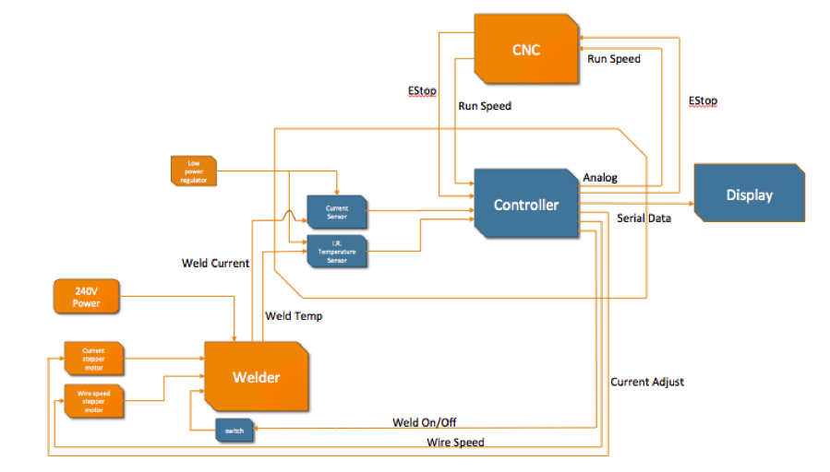

**Hardware:**

# Welder Control:

To control the welder, a central control module will be used. A Sensorray 826 PCI I/O Card will be used to control the settings of the welder, based on the state of the weld.

To control the current to the weld and the wire speed of the welder, two stepper motors have been fitted to the the manual control knows, and are connected to a motor driver module. The Sensorray board will be controlling the motor drivers using a sequence of rising and falling edges.

To allow the controller board to control at what time the welder is depositing and when it is not depositing, a relay with a transistor driver will be used.

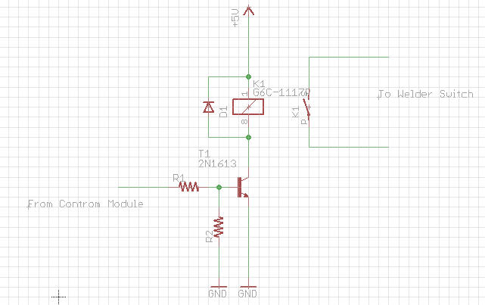

The signal to that tells the controller will be coming from the CNC machine's I/O card. It is a switch type signal whicm means that when the signal is sent, an internal switch will be closed, causing what ever is on the input to be shown on the output. The CNC machine uses G-Code, and Linuix CNC allows outputs to be asserted when a particular G-Code instruction is executed. G1 and G0 are going to be used to tell the I/O card to close and open the switch, which will assert 5VDC to the input to the control module. The control module will assert an output high or low which will open or close the welder switch, turning the welder on and off.

The Sensorray 826 I/O card has three 50 pin connectors and a single 26 pin connector. To allow easy access to these pins, a breakout board with screw terminals has been made so that wires can easily be disconnected and switched.

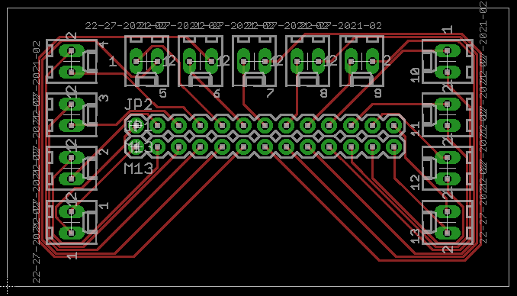

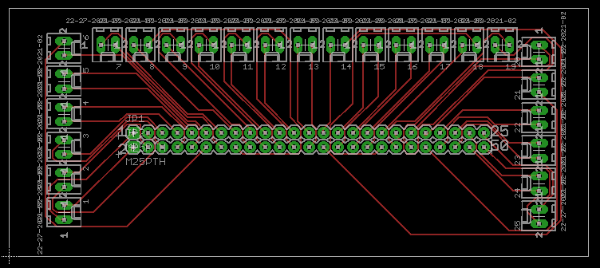

**Software**

# GUI Description

Our software will have a GUI in which the user can see real-time graphed data coming from the current and temperature sensors as well as see the current wire speed. The system should use this feedback to automatically adjust the weld and keep it in a state that can be considered a "good weld". Also included here will be manual overrides for the user to adjust the current and wire speed to their own desired result. Below is an initial GUI layout that we will be aiming for.

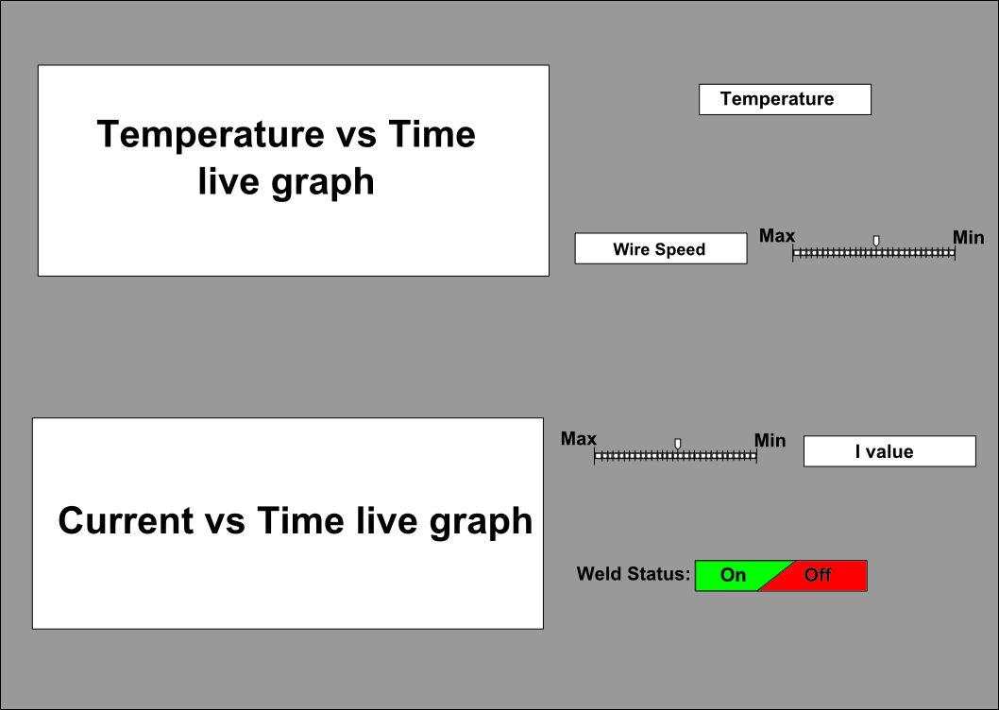

**The Graphical User Interface (GUI)**

We are using *GTK+* in C programming language to generate the Graphical User Interface in order to view the different data and also control different settings.

The *GTK+* is a library for creating graphical user interfaces. The library is created in C programming language. The GTK+ library is also called the GIMP toolkit. Originally, the library was created while developing the GIMP image manipulation program. Since then, the GTK+ became one of the most popular toolkits under Linux and BSD Unix. Today, most of the GUI software in the open source world is created in Qt or in GTK+. The GTK+ is an object oriented application programming interface. The object oriented system is created with the Glib object system, which is a base for the GTK+ library. The *GObject* also enables to create language bindings for various other programming languages. Language bindings exist for C++, Python, Perl, Java, C#, and other programming languages.

The GTK+ itself depends on the following libraries.

* Glib
* Pango
* ATK
* GDK
* GdkPixbuf
* Cairo

**Reasons for using *GTK+***

* *Language Bindings*

GTK+ is available in many other programming languages thanks to the language bindings available. This makes GTK+ quite an attractive toolkit for application development.

* *Interfaces*

GTK+ has a comprehensive collection of core widgets and interfaces for use in your application.

* Windows (normal window or dialog, about and assistant dialogs)
* Displays (label, image, progress bar, status bar)
* Buttons and toggles (check buttons, radio buttons, toggle buttons and link buttons)
* Numerical (horizontal or vertical scales and spin buttons) and text data entry (with or without completion)
* Multi-line text editor
* Tree, list and icon grid viewer (with customizable renderers and model/view separation)
* Combo box (with or without an entry)
* Menus (with images, radio buttons and check items)
* Toolbars (with radio buttons, toggle buttons and menu buttons)
* GtkBuilder (creates your user interface from XML)
* Selectors (color selection, file chooser, font selection)
* Layouts (tabulated widget, table widget, expander widget, frames, separators and more)
* Status icon (notification area on Linux, tray icon on Windows)
* Printing widgets
* Recently used documents (menu, dialog and manager)

**Examples of GUIs created using GTK+**

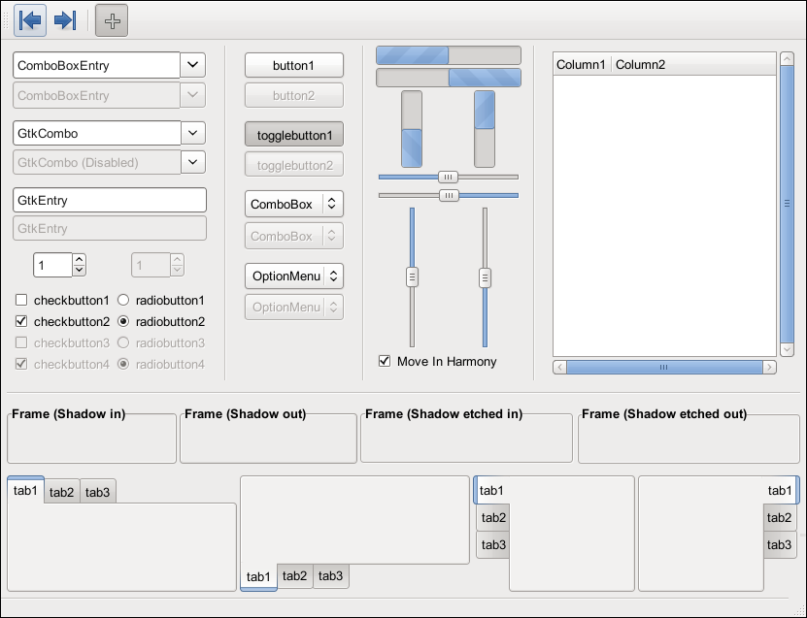

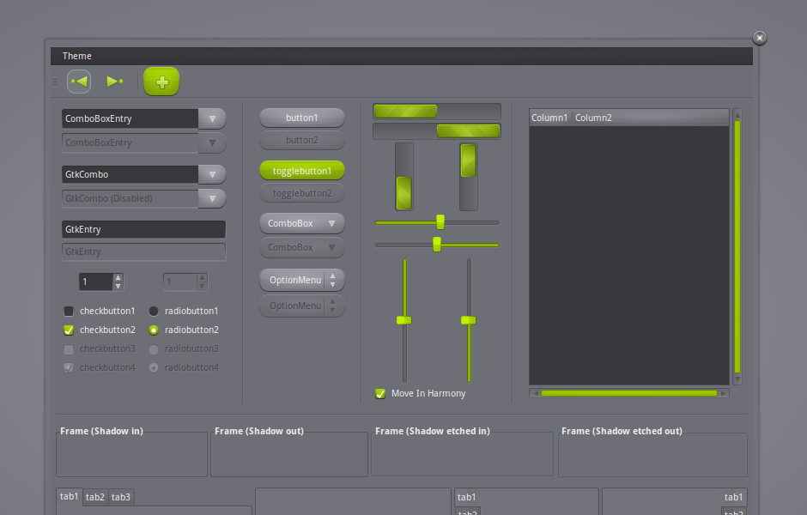

**Photos of Progress**

One of the fist things done in this project was to confirm the operation of the CNC machine. To do this, G-Code of a 2D image was uploaded to the machine. A felt marker was used to draw the image below.



Next, we fitted the welder to the machine, and placed a metal base plate to weld on. To control the welder we just used our hand to active the weld while the machine was moving.

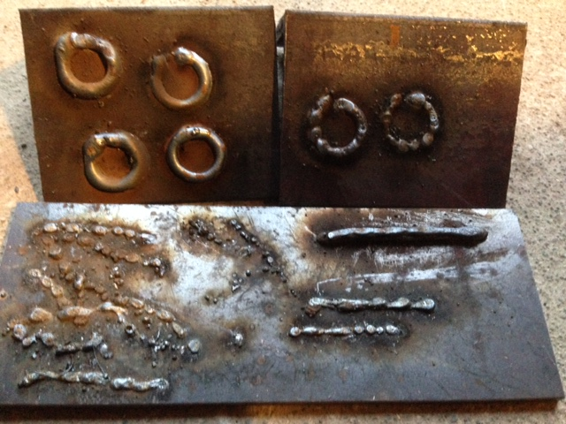

After this, we connected the relay switch circuit in parallel with the manual welder switch, using G-Code to activate the switch.

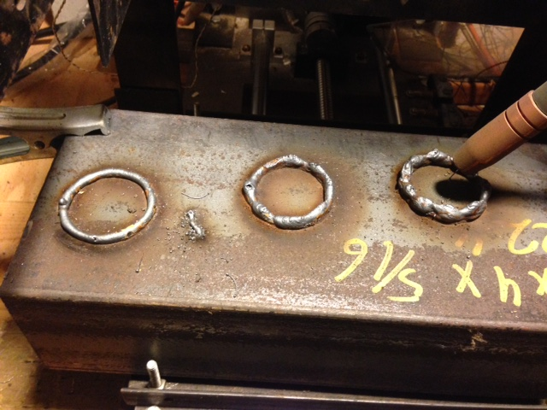

**Test Plans ??**